|  |
| --- |
| fmdss logo medium.png |
| **API Requirement For Here Map Rajdharaa** |
|  |

**Prepared By**



Table of Contents

1 Introduction 3

1.1 Purpose 3

2 Requirement for Fmdss Mobile Application not limited to:- 3

2.1 Raster Service 3

Use Cases 3

Interface:- 4

Exception Message:- 4

2.2 Direction Service:- 4

User Cases 4

Interface:- 5

Exception Message:- 5

Non Functional Requirement:- 5

E.g.:- 5

Testing:- 6

Open Issues 6

Reference 6

# Introduction

# 1.1 Purpose

The purpose of this document integration Geospatial Service available from RajDharaa (HERE Map Services) for Forest mobile application integration with HERE Map.

# Requirement for Fmdss Mobile Application not limited to:-

* Raster Service for overlaying Forest fire
* Direction service between two geolocation

# 2.1 Raster Service

We required "Raster Service" to visualize forest fire location for data overlay.

# Indicative Functional Requirement

|  |  |  |
| --- | --- | --- |
| Sl No | FMDSS Input | RajDharaa HERE Map requirement |
| 1 | Fire Lat/ Long in degree decimal will be supplied via calling HERE API | Both the points to be displayed with Raster Overlay interface |
| 2 | Based on the Fire location lat lon, application must display as info related to administrative details, and forest administrative details "NAKA","Range","Division","District" and "Village". |
| 3 | FMDSS require destination distance (Where Fire burns in forest) from current location along with distance and estimation arrival time as showing in above screen shot. |

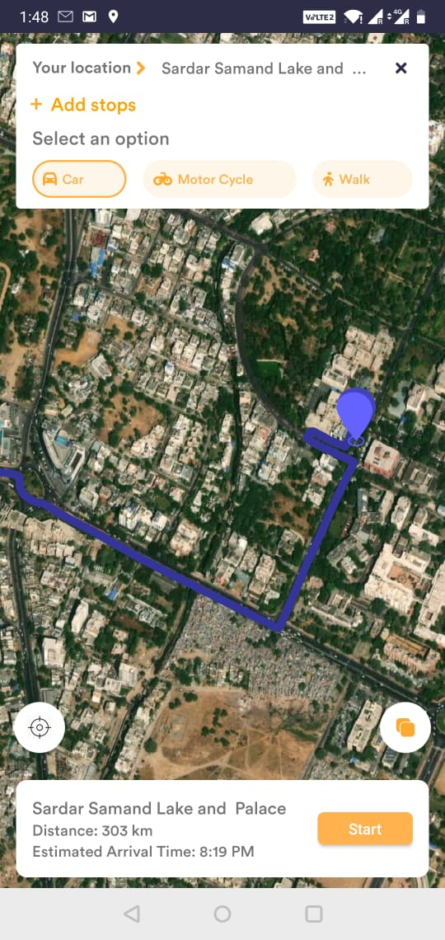

Pls refer above UI as shows in above screenshot for FMDSS mobile application.

# Non- Functional Requirement

* All API must support, Android & IOS platform.
* Map rendering must be fast based on standard configuration of mobile
* Exception handling
* Maintaining same same UI/UX
* Minimum 3G internet service is required

# 2.2 Direction Service: -

Require "Direction Service" between two points based on network topology and raster service as back drop.

# Indicative Functional Requirement

|  |  |  |
| --- | --- | --- |
| Sl No | FMDSS Input | RajDharaa HERE Map requirement |
| 1 | Fire Lat/ Long in degree decimal will be supplied via calling HERE API | Both the points to be displayed with Raster Overlay interface |
| 2 | Two point should be display one for current location and another for destination where fire is burn |
| 3 | FMDSS require destination distance (Where Fire burns in forest) from current location along with distance and estimation arrival time as showing in above screen shot. |
| 4 |  | Trajectory will be Draw, containing start and end position. |
| 5 |  | Map Interface functionalities like Zoom in Zoom out/Pan etc. |
| 6 |  | Based on current location calculate/approximated distance of destination where fire has burn will display |
|  |  | The user will have the option to filter the origin and transportation modes. (Walk, cycle, car, public transportation).  User can choose the designation by clicking on map.  User can filter mode (Satellite, Night, Day mode). |

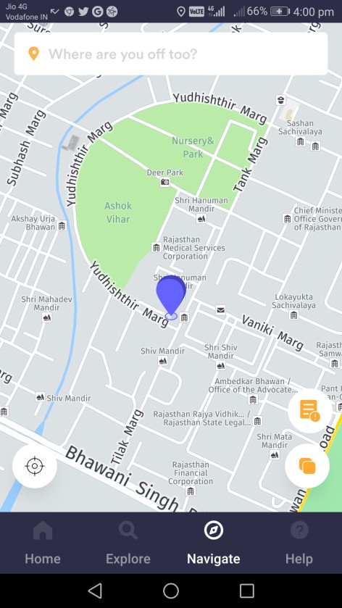 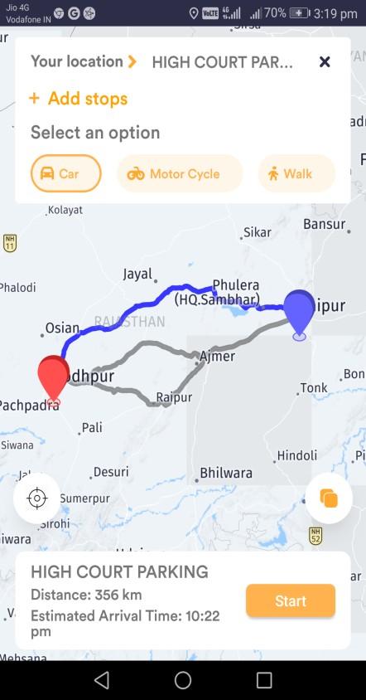

* We require interface as show in screenshot for FMDSS mobile application.



# Exception Message:-

* If any error or exception occurs while using mobile application then alert or message will display.

# Non Functional Requirement:-

* Access FMDSS mobile application required minimum 5.0 android versions.
* Minimum 3G internet service is required.

# E.g.:-

* If forest user click on "latitude" and "longitude" in FMDSS mobile application, then user should redirect to "Rajdharaa Here Map".

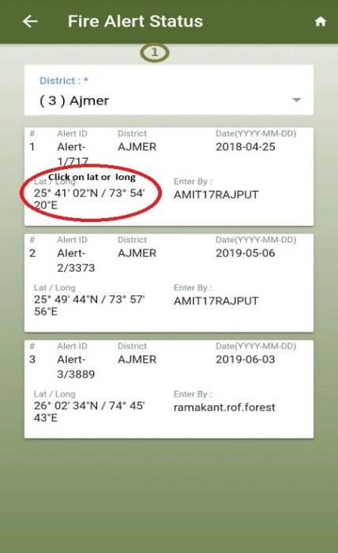 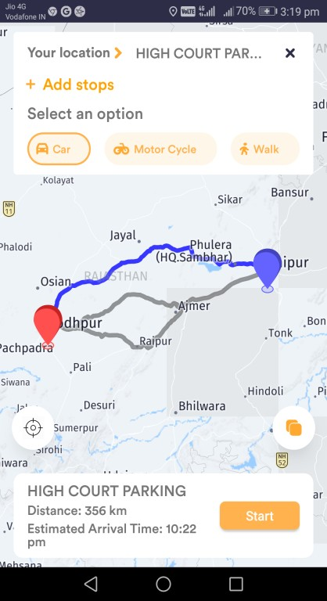

* In Here map location of fire burns will display along with distance from current location with date and time.
* In Here map all the possible route should display along with distance and time taken from each route.

# Reference

For reference FMDSS mobile application "https://play.google.com/store/apps/details?id=gov.fmdssforest"